EDM profile for Sounds
Collection of use cases

The Task Force on EDM profile for Sounds aims at creating an EDM profile for describing sounds materials. The first step in the process is the collection of use cases. These cases will allow the Task Force to scope its activities and define clear requirements that will form the basis of the EDM profile for Sounds.

The current fields for the use case templates are:

1) Title of the use case(s)

Boneyawa_01AI (Funny stories/narratives)

2) Owner's case name and name of the represented institution

Anna Margetts, speech community of Saliba Logea, TLA

Use case(s):
3) Provide a general description of your use case(s). You can also add to your use case(s) images, diagrams if needed.
A use should contain information on:
-what is the type of sound objects you provide Europeana (vinyle, recording, music sheet….)
-Are these objects composed of different elements? If yes, what is the type of the relationship between an object and its different components or between the components themselves?
-Do the objects have digital representations? And if yes, of what type (same recording in different formats, video, images…)?

Example from the report of the Task Force on Hierarchical Objects http://pro.europeana.eu/web/network/europeana-tech/-/wiki/Main/Taskforce+on+hierarchical+objects written by Rodolphe Bailly, Cité de la Musique.
At the Cité de la musique, a concert recording is documented as a hierarchy of records.
The first, top level record describes the "concert". It contains general information about the recording of the concert itself, such as title, date, location and the most important performers and composers. The other records describe the "constituents" of the concert, i.e. the musical works performed during the concert. Each of these constituent, situated at a lower level of the hierarchy, contains detailed information about the performed musical works (for instance the complete list of performers). If needed, each of the performed musical work record may also have constituent records, such as specific parts in a symphony.
This concert recording can be represented as follow:
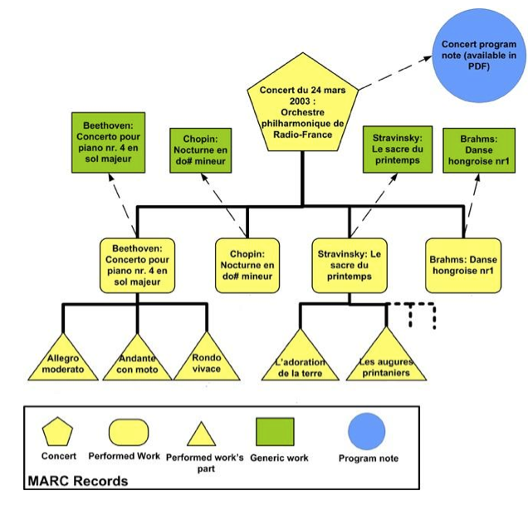

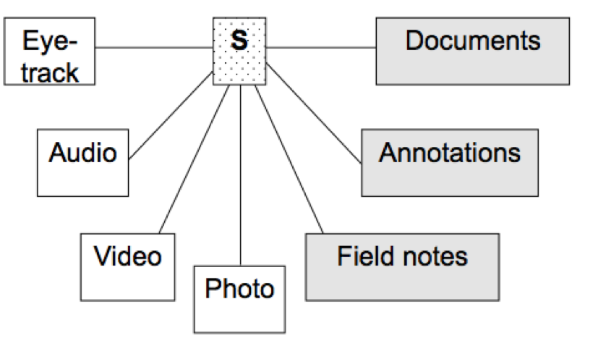

Our archive is digital only. We provide so called sessions in our metadata tree (see figure above – ‘s’). These sessions contain metadata informing generally about where data comes from, who are actors in the data, who has gathered the data, the linguistic project, the type of content (genre, subgenre, task, modalities, subject, interactivity, planning type, involvement, social context, event structure, channel – some using closed vocabulary) etc. These are based on IMDI-categories. The kind of resources connected to the session is also indicated - AMONG which audio-resources (see figure above – audio on the left). These resources are usually wav-files (single files attached as resources to the sessions), containing linguistic data recorded during fieldwork. The kind of material though varies from songs, monologues, dialogues, conversations with researchers, narratives told in a certain culture. Metadata about audio-resources uses the metadata-categories used for other mediafiles (such as images, videos): For our use case the information would be

Type – audio (cv)

Format - audio/x-wav (cv/open)

Size - 22 MB (numeric)

Quality – Unspecified (cv)

Recording Conditions: /

a) time position

start: /

end: /

b) access

availability: /

date: /

owner: /

publisher: : /

contact (name, address, email, org): : /

description: : /

c) description: / (possible to choose language of description –cv)

For our use case the general information mentioned above would be:

1) Session

Name: Boneyawa_01AI

Title: Boneyawa 01

Date: 2004-10-15

2) Location

Continent: Oceania (cv)

Country: Papua New Guinea (cv/open)

Region: Milne Bay Province (open)

Region: Alotau (open)

Address: Alotau (open)

3) Project

Name: Saliba/Logea

Title: Towards the Documentation of Saliba and Logea Language and Culture

Id: /

Contact (name, address, email, organization): /

3.1) Contact

Name: Anna Margetts

Address: School of Languages, Cultures & Linguistics, Clayton Campus, Monash University, Victoria 3800, Australia

Email : Anna.Margetts@email.com

Organisation: Monash University

3.2)

Description: / (description language can be chosen –cv)

4.) Content

Genre: Discourse (cv/ open)

Sub Genre: Narrative (cv/ open - multiple)

Task: Unspecified (cv/open)

Modalities: Speech (cv/open -multiple)

Subject: Unspecified (cv/open -multiple)

Interactivity: non-interactive (cv)

Planning Type: semi-spontaneous (cv)

Involvement: Unspecified (cv)

Social Context: Family (cv)

Event Structure: Monologue (cv)

Channel: Face to Face (cv)

4.1) Language

Id ISO639-3: sbe (cv)

Name: Saliba

Dominant: true (cv)

Source Language: Unspecified (cv)

Target Language: Unspecified (cv)

Description:
Saliba and Logea (also Sariba and Rogeia) are two closely related dialects spoken on neighbouring Islands as well as on adjacent parts of Sidea Island and the mainland in Milne Bay Province of Papua New Guinea (PNG). There are also a small number of speakers on Samarai Island, the local commercial centre, in the provincial capital Alotau, and in Port Moresby, the capital of PNG. According to the national census of 2000 the total number of Saliba and Logea speakers is about 2,500. Saliba/Logea is a Western Oceanic language belonging to the Suauic family of the Papuan Tip Cluster. The two dialects are mutually intelligible and speakers describe the main distinction between them as one of tune and rhythm. There are also some lexical differences but the percentage of shared vocabulary is very high. Differences in the grammar of the dialects have so far not been established. (Possible to choose description language – cv)

4.2) Description

AI tells a Boneyawa (funny story) about a boy who thought he could carry light in a basket (Possible to choose description language – cv)

5.) Actors

Description: AI is the sole story teller

5.1) Actor

Actor: AI

Role: Consultant (cv)

Name: AI

Full Name: AI

Code:_AI

Family Social Role: Unspecified (cv/open -multiple)

5.1.1) Language

Language: Saliba (possible to choose description language – cv)

5.1.2)

Ethnic Group: Saliba

Age: 58 (numeric)

Birth Date: Unspecified (numeric)

Sex: Male (cv)

Education: Unspecified

Anonymized: / (cv)

5.1.2.1 Contact

Name: /

Address: /

Email: /

Organization: /

5.2) Actor

Actor: Anna Margetts

Role: Collector

Name: Anna Margetts

Full Name: Anna Margetts

Family Social Role: Unspecified (cv/open -multiple)

5.2.1) Language

Language: / (possible to choose description language – cv)

5.2.2)

Ethnic Group: /

Age: / (numeric)

Birth Date: / (numeric)

Sex: / (cv)

Education: /

Anonymized: / (cv)

5.2.2.1 Contact

Name: /

Address: /

Email: /

Organization: /

Data sample illustrating the use case
4) Each use case should be illustrated by (a) data sample(s).
Upload your data sample(s) at https://drive.google.com/folderview?id=0B4N3jJ2PToabWU1scDVFZGVKVEU&usp=sharing and indicate the name of the file(s) in this questionnaire for reference.

Boneyawa_01AI

5) What metadata format is used in the samples(s)?

IMDI XML

6) Describe how you use this metadata format to support the described use case(s) (can include details on specific metadata elements, data quality aspects…)

IMDI – categories are designed to give general information about sessions containing resources. Additionally users can flexibly add categories such as “language” in order to elaborate on attributes of an “actor” as they wish. The information revealed in this metadata for the sessions – also containing metadata on each resource (here relevant: audiofiles) – serves to place the resources presented in a context and to enable users to have background information for understanding the contents and ways of presentations of the contents of the audio-material.

Vocabularies
7) Are you using specific vocabularies(e.g. thesauri) to describe information such as subjects, genres in your metadata?
If not go to question 11.

Some IMDI metadata categories are based on closed vocabulary.

8) If yes, how are you using them? In which metadata fields?

There are drop-down lists the owners of the audio material can make use of to fill in the metadata. This applies for various fields: for our sample we indicated the controlled vocabulary fields above – see “(cv)” behind descriptions in answer 3 (“open/cv” refers to the user being in position to choose for making used of controlled vocabulary or not; “multiple” means that several controlled vocabularies can be chosen for one metadata description field)
For more detailed information, check:
www.mpi.nl/IMDI/Schema/Schema.zip

9) What is the language coverage of these thesauri/vocabularies?

English

10) How are the thesauri/vocabularies represented (e.g. a database, an XML file, SKOS, etc.)? If possible provide an example of (a part) of the thesauri/vocabularies you use (e.g. a fragment of XML, etc.).
Copy and paste an example in the questionnaire or upload your vocabulary sample at https://drive.google.com/folderview?id=0B4N3jJ2PToabWU1scDVFZGVKVEU&usp=sharing and indicate the name of the file(s).

XML

www.mpi.nl/IMDI/Schema/Schema.zip

Enrichment
11) If you are not using thesauri/vocabularies, would you like to see your metadata enriched with references to thesauri/vocabularies?

/

12) Which metadata fields would you like to see enriched?

/

